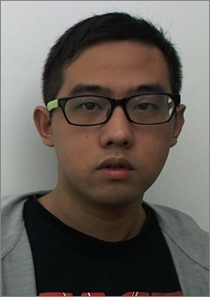
Wang Kairui
Birthday：12-09-1992
Phone Number：+86 15062791972
E-mail：903328126@qq.com
Education Background
From 09.2015 to 10.2016, University of Hertfordshire, School of Computer science, Master of Science,
Software Engineering
From 09.2014 to 07.2015, University of Hertfordshire, School of Engineering and Technology, Bachelor's degree of Science, Multimedia Technology
From 09.2011 to 07.2014, Changzhou Institute Of Technology, School of Computer science, Bachelor's degree of Science, Software Engineering

Project Experience
Project Date：From 10.2015 to 01.2016
Project Name：Kaspar Robot for Autistic children
Job in Project：Requirement analysis
Introduction：As the high percentage of British children suffering from autistic symptoms. The project aims to cure autistic children by the artificial intelligence robot. Researchers hope children are happy to communicate with the human-computer interaction. The group members need to collect data according to current functions and analyze user cases. The new functions would be designed based on the original functions.
Works: 1.Designing personas; 2. Analyzing and studying current system, creating user and usage modeling; 3. Requirement gathering; 4.Writing requirement analysis document.

Project Date：From 02.2015 to 05.2015
Project Name：Ski Friend
Job in Project：Software development
Introduction: Ski Friend is a windows phone application for British people who love to ski. It aims to help new player learn more about skiing and also give all players more immediately information about ski resort.
Works: 1.Feasibility study; 2.Software requirement analysis and writing codes; 3.Software test; 4.Future plan.

Extracurricular activity
From 14.10.2013 to 25.10.2013, Student volunteer in 8th China flower EXPO.
- Maintaining the order
- Guiding and introducing flowers

Skills/hobbies
Language: IELTS 5.5 / 9; CET-4 479 / 710; 3 years study experience in the UK
Professional skills: Familiar with C# ，Can use Photoshop，3Ds Max，Good at Word，PowerPoint，Excel
Hobbies: Basketball，Point guard in school basketball team；DOTA2，Run-up in University E - sports contest.

Self-evaluation
I am optimistic, cheerful and positive. I have played a couple important roles in the student organizations, honed the interpersonal communication skills and organizational capability. When I studied in university, I completed all the courses in the specialized field. I am very adaptable and good at leaning.

